**Microservice**

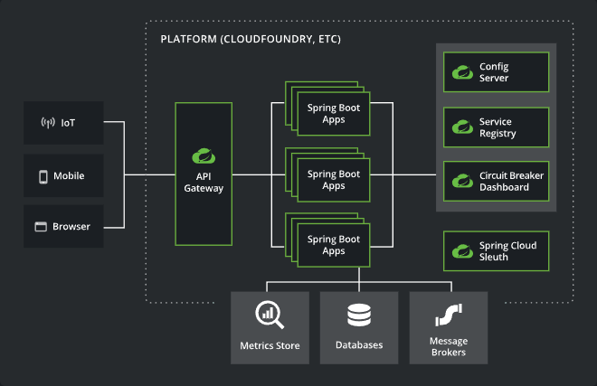

**Service Registry**



**@LoadBalanced**

* When more than one instances is present in service then it will distributes this load.
* It help to enable us to call directly name of the services rather than host of the services.

**Feign Client**

* It is Declarative HTTP web Client developed by Netflix.
* It fallow Declarative Approach
* Now Declarative approach means we need to declare the things in Advance, We have to declare interface and inside that we need to add Annotations in that then it will call methods automatically.

1. First we need to add Dependency in our microservice project – **OpenFeign**
2. Now we can Create a package name externalservices and in that we create Interface.
3. In this interface Add the annotation on Class level **@FeignClient(name = “NAME-SERVICE”).**
4. After that we need to create a method in Interface Same as we Controller.
5. Give the respective annotation on method.
6. Now call those method where we want call RestApis in the service class.

**API Gateway**

**Config Server**

Add Config Server dependency